|  |  |  |  |  |  |  |  |  |  |  |  |  |  |  |  |
| --- | --- | --- | --- | --- | --- | --- | --- | --- | --- | --- | --- | --- | --- | --- | --- |
| ***2019 Participant Information*** (Please PRINT) | | | | | | | | | | | | | | | |
|  | | | | | | | | | | | | | | | |
| Name: | |  | | | | | | | | | | | | | |
| Address: | | |  | | | | | | | | | | | | |
| City: |  | | | | | | State: | |  | | | Zip: |  | | |
| Phone: | |  | | | | Cell: | |  | | | | | | | |
| Email Address: | | | |  | | | | | | | | | | | |
| Organization Position or Youth: | | | | |  | | | | | Unit: |  | | | Age: |  |
|  | | | | |  | | | | |  |  | | |  |  |

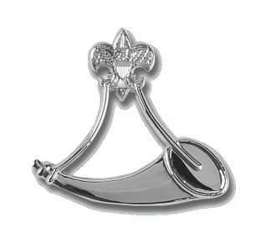

Registration Form

### Learning Objectives:

After completing the Powder Horn Course participants should have sufficient introductory information to provide the following outcomes:

Introduction to the necessary skills to   
 oversee a high adventure program, and   
 the certifications necessary (and how to   
 obtain those certifications).

Knowledge of the health and safety   
 requirements, and rules and regulations   
 of the Boy Scouts of America as these   
 apply to outdoor programs.

Knowledge of how to identify local   
 resources and consultants for outdoor   
 high adventure activities.

### Participant Qualifications:

Be able to meet the physical requirements   
of the BSAs Annual Health and Medical Record for a high adventure in a backcountry environment.

**H**ave you ever had your Youth suggest a high adventure activity and thought, “Sounds nice, but I don’t know a thing about it...nor do I know anybody else who does.” Powder Horn can help…

**O**neof the criteria for a high adventure program is “a risk factor for excitement.” The Powder Horn outdoor high adventure skills course is designed to introduce you to the excitement, resources and tools to guide your young adults in a wide range of high adventure program features.

**T**he course covers the following topics:

Archery, backpacking, caving, communications, conservation, cooking, COPE (high & low), mountain biking, ecology, emergency preparedness, equestrian, expedition planning, fishing, land navigation, leave no trace, outdoor living history, plants & wildlife, SCUBA experience, shooting sports, water sports, wilderness first aid, wilderness survival, and MORE!







Enclosed is a $75.00 deposit to confirm my reservation for the 2019 Summer Course. I will pay the balance of $120.00 no later than July 1, 2019.

I understand that this is a ***physically demanding*** “high adventure course” that requires medical practitioner approval on a current BSA Annual Health and Medical Record form, prior to “day one” of the course. I affirm that I am registered with the BSA, in good standing, and will have completed the appropriate adult leader training before attending.

Signature: _____________________________

Date: _________________________________

**Registration Information**

**Course Fee:** $195.00 Total for the Course

($75.00 Deposit due with application. Balance due 30 days prior to the course “start date.”

**Medical Form:** Participants **MUST** submit a current BSA Annual Health and Medical Record (Parts A/B), which should be submitted with final payment 30 days prior to the course.

**Course Size:** Course will consist of at least 20 and not more than 48 participants. Once the course is filled, participants will be given the option of being placed on a waiting list in case of cancellations.



powderhorn shirt2

**Mail-In Registrations:** Send deposit, registration form, & a **copy** of your Health and Medical

Record to the: **Grand Teton Council, BSA   
 Course Director - Powder Horn Course  
 3910 Yellowstone Ave. Idaho Falls, ID 83402**

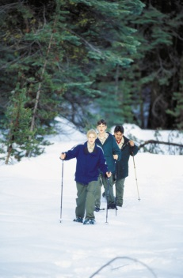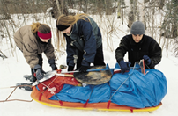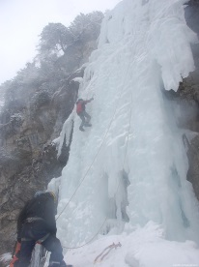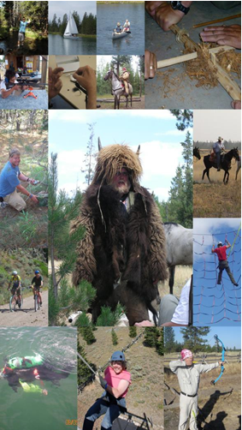

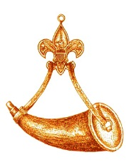

Powder

Horn

POWDER HORN

Why High Adventure for Youth?

A High Adventure Program can teach…

* Decision-making
* Creativity, Discipline
* Leadership, Endurance
* Facing Risk and Uncertainty
* Working in Groups
* Identifying Strengths
* Citizenship, Service
* Concern for others
* Personal Development

**Course Director:**

**Richard Turpin**

**208-522-5155**

**Richard.turpin@scouting.org**

The powder horn was long used by outdoorsmen as one of the most necessary tools for existence. The powder horn carried the propellant that allowed him to sustain daily life.

The powder horn ranged from the very plain, yet functional, to the ornate work of art, but its use was the same: a Vessel to sustain.

The recipient of the Powder Horn recognition is also a Vessel... to help sustain the spirit of adventure and excitement of the old outdoorsman in our youth.

The propellant that we carry is the knowledge to share with them.

Outdoor High Adventure Skills & Resources Course

Also open to youth

14 – 20 years old

Powder Horn is designed to have many disciplines introduced with numerous hands-on activities. Participants not only actively join in the working sessions, but learn where to go to find those experts or consultants who can teach these skills to Boy Scouts, Varsity Scouts, and Venturers.

**A most valuable resource is the consultant, a person whose expertise will teach skills, as well as guide and enhance high adventure experiences.**

...is a training course designed to introduce and

expose adult and youth leaders to...

... activities and resources necessary to operate a successful high adventure outdoor program. The Powder Horn course is a resource for all units conducting activities in the outdoors.

It is intended to help adult and youth

leaders become familiar with activities

available to youth, learn how to find

and to use those available resources

in a way that adds variety and

challenges to the youth in unit-level

high adventure programs.



Powder Horn