2018 Grand Teton Council - Boy Scouts of America

TOP 100 CLUB - “BIG SPIN PARTY”
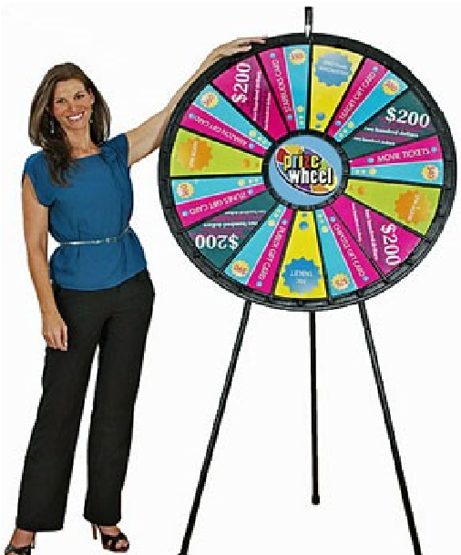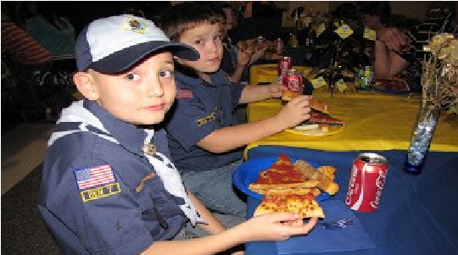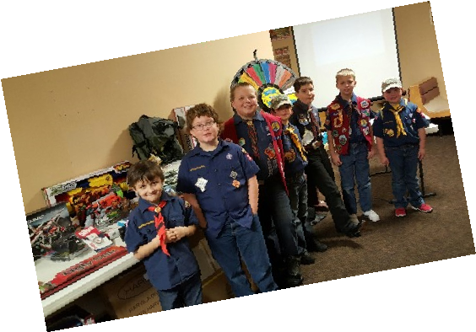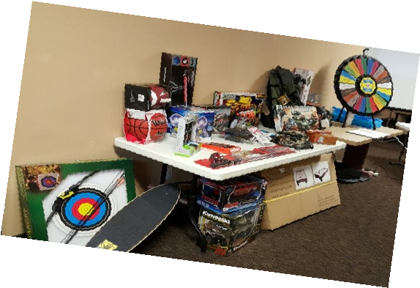

SELL A MINIMUM OF $1,200 IN POPCORN FOR A CHANCE TO JOIN THE CLUB!

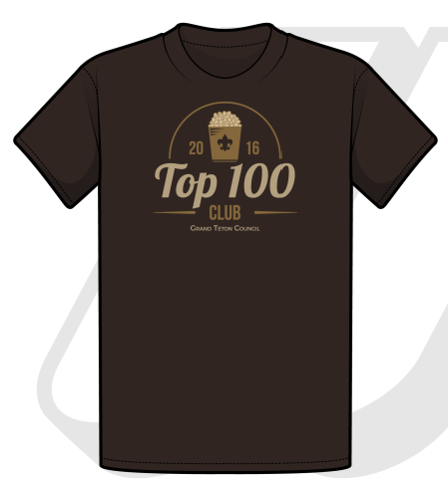
- Only the Top 100 sellers in the council will be invited!
- Receive a Free Top 100 Club T-Shirt!
- Earn more spins on the Big Spin Prize Wheel
with every additional $1,200 you sell!
- Join the club for food, fun, and awesome prizes!

Saturday, January 5, 2019
Location: TBD
Idaho Falls

Top 100 Sellers Club Form
**must sell a minimum of $1,200 to be eligible!**
Unit Type (circle one): Pack Troop Crew Ship Unit Number: $ Popcorn Sold:

Phone:

Name:

Address:

City:

Email:

State:

Zip:

T-Shirt Size:  YS  YM  YL  S  M  L  XL  2XL  3XL
**Only Scouts who make the Top 100 Sellers Club will receive their Free T-Shirt**

