HOW TO GUIDE FOR TAKING ILLEGAL HARASSMENT TRAINING
1. Go to https://www.skillsoftcompliance.com/Academy/Commonui/login.aspx?ReturnUrl=%2facademy%2fdefault.aspx%3forgid%3d551502&orgid=551502
2. Enter your User name and Password OR click on New User? Click here to Register.
This will be entirely different login credentials than your MY.SCOUTING
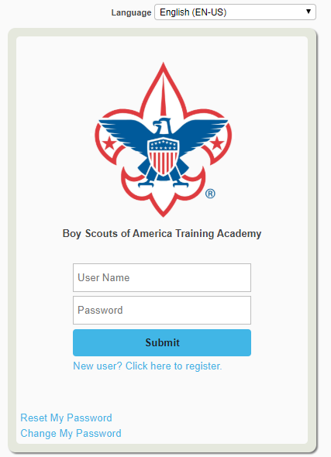
3. When you Register for a New Account you will pick a User Name, Password, Enter your First Name, Last Name and Email Address. Then, in the Employee Type Field, select Employee.
In the Location Field select Grand Teton Council (107). Finally, Click Continue
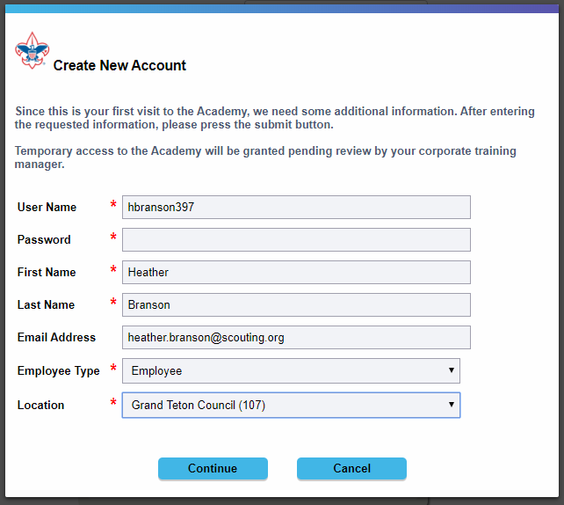
4. You will be directed to your Home Page of the Boy Scouts of America Training Academy.
Click on the Learning Plan Icon next to the Home button in the top left of the page
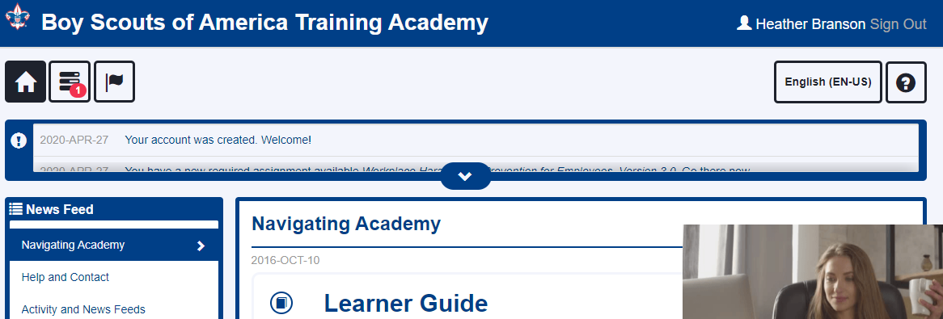
5. You will be directed to the Learning Plan Page. Under Required Assignments you will have the Course.
Click on the Green Arrow to Begin the Training
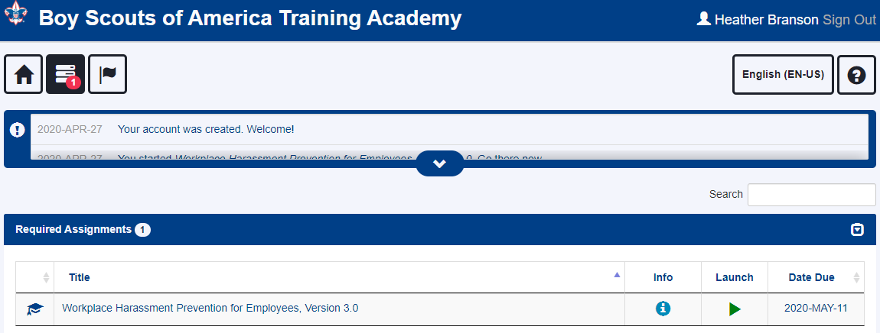

6. A Pop-Up Window will open with the following disclaimer. Please read it and if you agree with the statements listed Click on the Button
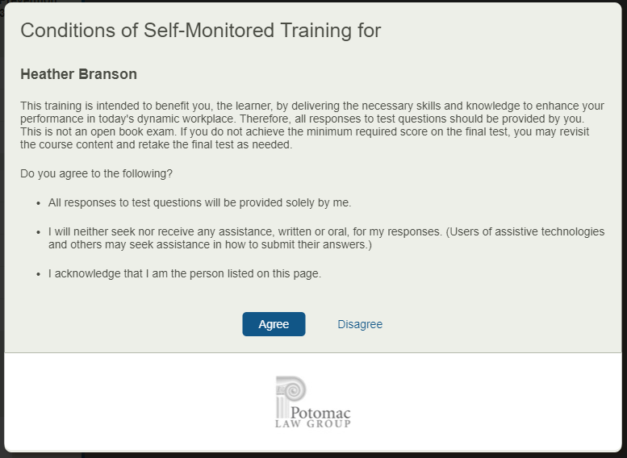

7. Once you Agree, you will be taken to the “Workplace Harassment Prevention for Employee Training Modules. There are 10 modules to work through and then the Course Test. The entire training takes about 35-45 minutes. You will begin each section by clicking the button.
In order to meet timing for state regulations, you will not be able to fast forward (the button will be grayed out) until the audio finishes playing for each slide. Once the audio is completed, the button will appear. Click the button to proceed.

You have several navigation tools to use during your training.
Learning Points Menu Transcript Menu Back Button Next Button Settings Button Audio Description Button
This will take you back to the This gives you a readable Takes you back to Moves you to the Allows you to enable Turns on and off the audio
beginning of the chapter transcript of the module the beginning of the Next section and disable settings description setting
section
Pause/Play Button Audio Controls Previous Topic Button Next Topic Button Closed Captioning Button
Pauses and resumes the Volume control Takes you to the previous Skips to the Next Chatper Turns on and off the Closed Captioning
Videos in each section chapter

8. Once you have completed all the chapters, you will end on this screen. Click on to begin the test on this material
9. Once you have finished the test you will see this screen. Hopefully with a 100%, however if you need to retake it please do. Then click the button.
10. This will take you to the Screen where you can print you test report. Please click on the button.
11. That will open your report, you will print here by clicking the button and print it as a PDF.

12. Once printed this will take you back to your lessons plans page and will show that you have completed the Harassment Prevention Training.
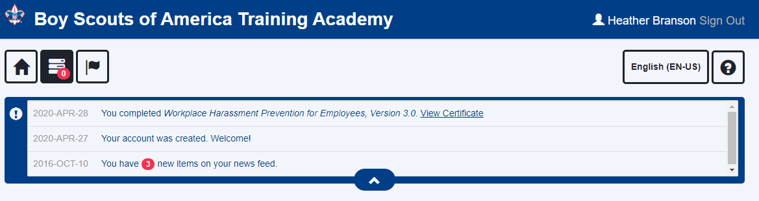
13. Please email your Training Report to gtccampstaff@gmail.com

