Troop # ___________ Date of Election _______  Is Troop or Team eligible to hold an election ☐ Yes ☐ No  Location of Election ________________________________  District __________________________________________ |  |  |  |  | 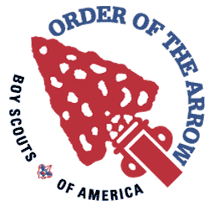  Order of the Arrow  Grand Teton Council #107  Shunkah Mahneetu #407  Unit Election Form
Scoutmaster/Varsity Coach must read and certify the unit election and membership requirements prior to unit elections (see cover page)
First Name* | Last Name* | Rank* | Street/City/State/Zip* |  |  |  |  | Phone (Parents)* | Birth Date* | Elected
 |  |  | Email (Parents)*
 |  |  |  |  |  |  |  |  |  | ☐
 |  |  |  |  |  |  |  |  |  | ☐
 |  |  |  |  |  |  |  |  |  | ☐
 |  |  |  |  |  |  |  |  |  | ☐
 |  |  |  |  |  |  |  |  |  | ☐
 |  |  |  |  |  |  |  |  |  | ☐
 |  |  |  |  |  |  |  |  |  | ☐
*These are required. Please print legibly.
Number of Members eligible to be elected: |  |  |  |  |  | As unit leader, I certify, by my signature, that the above youth members are eligible, according to the youth member qualifications, and approve them as nominees for election and that we have read and understand the requirements on the cover page of this form
Number of votes required to be elected:
Number of ballots turned in:
Number elected:
OA Election Team Signatures |  |  |  |  |  | Unit Leader Signature:
 |  |  |  |  |  | Unit Leader Printed Name:
 |  |  |  |  |  | Unit Leader Address:
 |  |  |  |  |  | Unit Leader Email:

